Getting to Explore the Kodály Method of Music Education

Thanks to the Office of Student research, I was able to further research the Kodály method of teaching music. To do this research, I chose to attend the Organization of American Kodály Educators national convention in Minneapolis, Minnesota. Before I left, I read many books and articles to familiarize myself with the basics of the method. I wanted to do this so I could learn more about the details and how the method is really used in the everyday classroom. Also before I left, I interviewed a few music teachers to see what elements of the method they used in their classrooms and why they chose those particular aspects. This allowed me to begin to see what I was reading put into action. While I was at the convention, I was able to learn more about the details that go into carrying out this method in all sorts of different classrooms. I was also able to meet Kodály educators from all over the country and learn how flexible this method really is. It can be used in a K-12 district or an inner city district. I learned about the different levels of certification and how to become an officially Kodály certified educator. I have attached a separate document of most of my findings at the convention that I used to give at my Student Research Presentation.

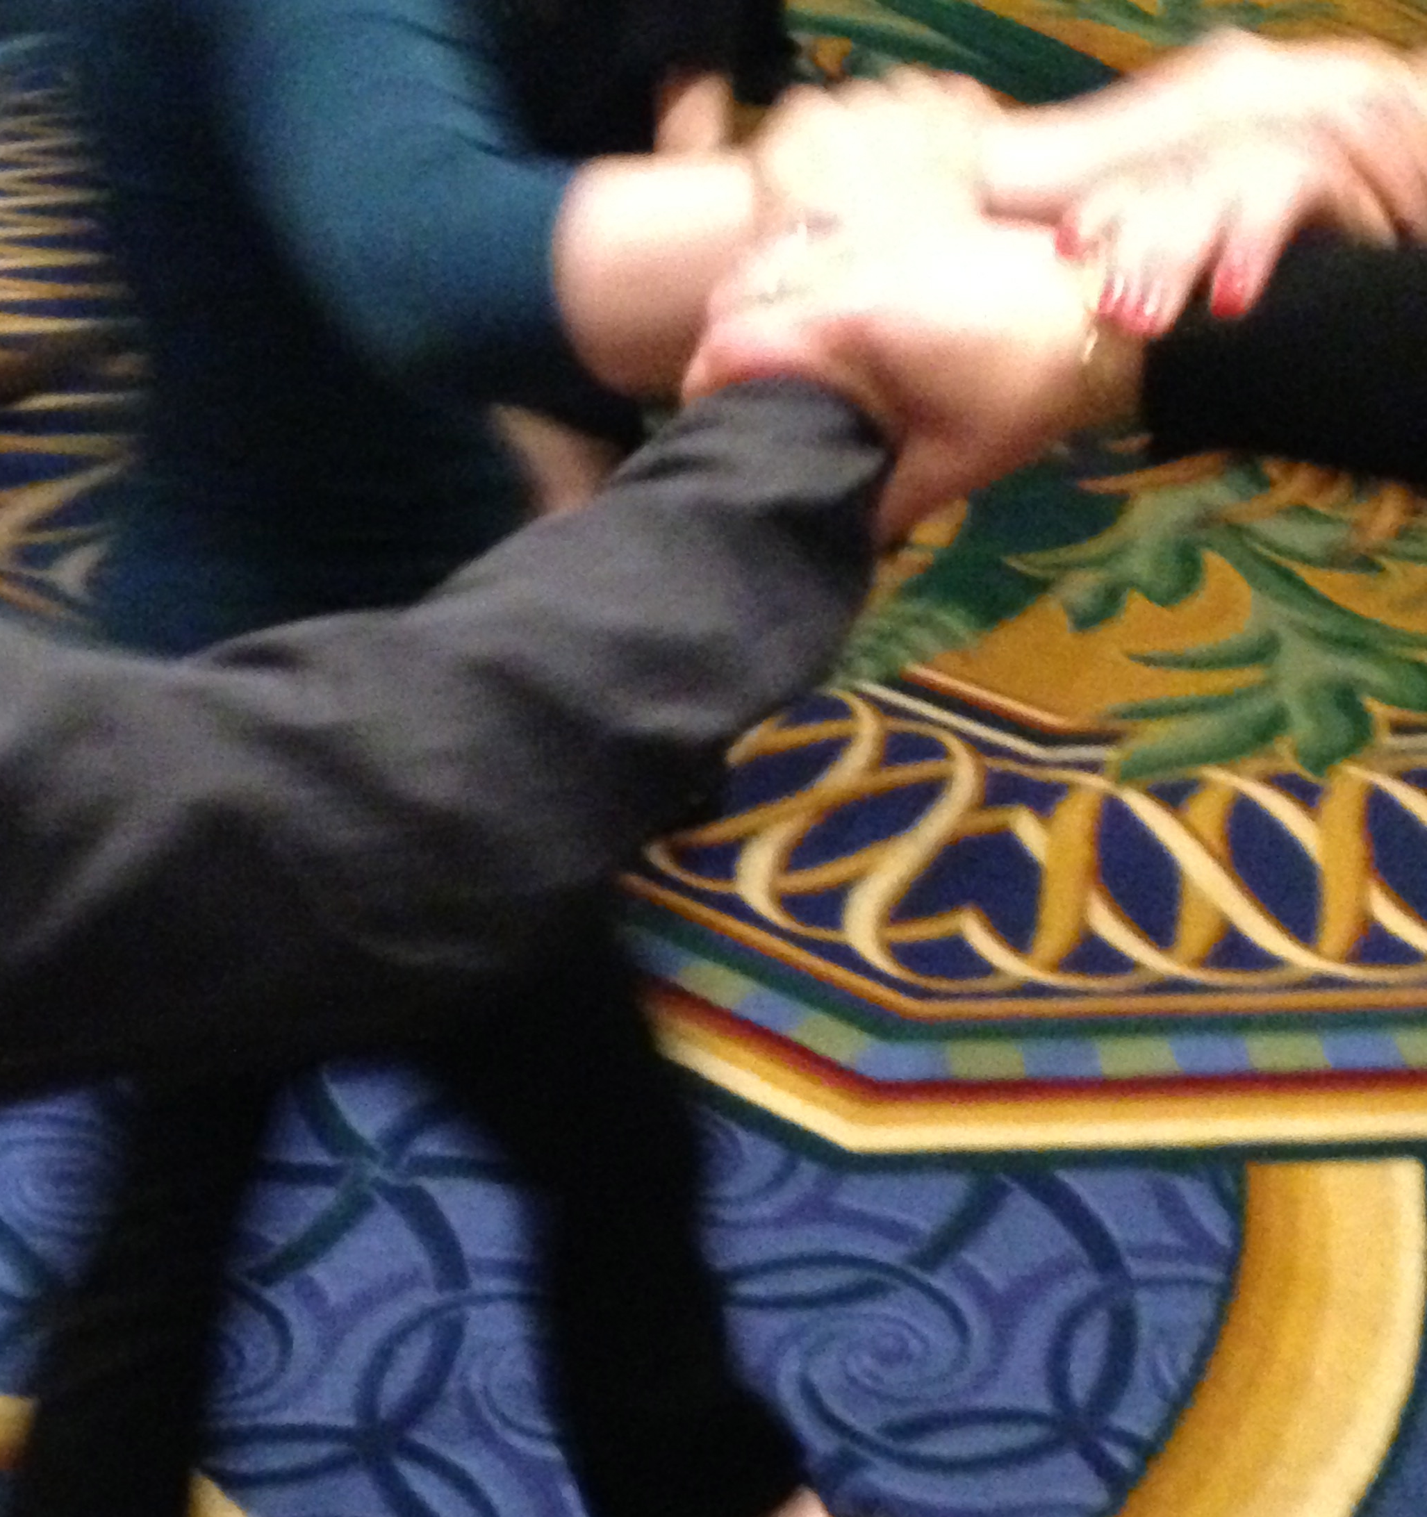

Leaning about star-knot used for play parties

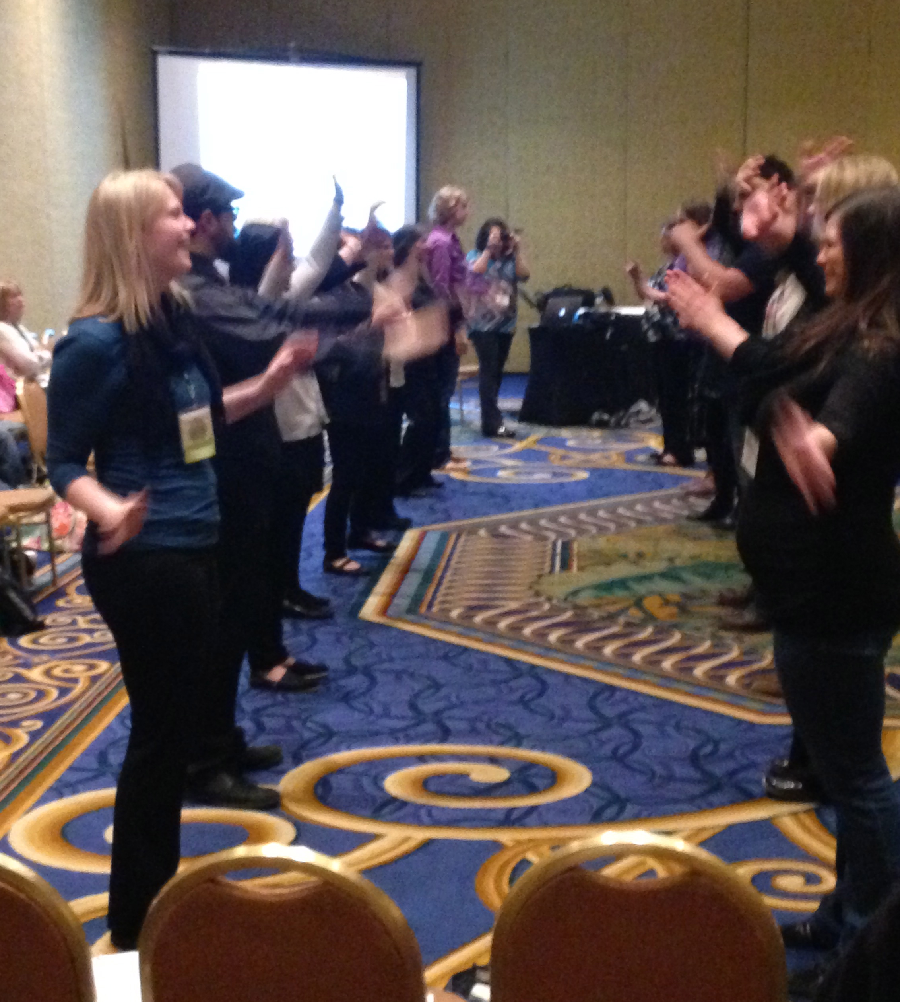
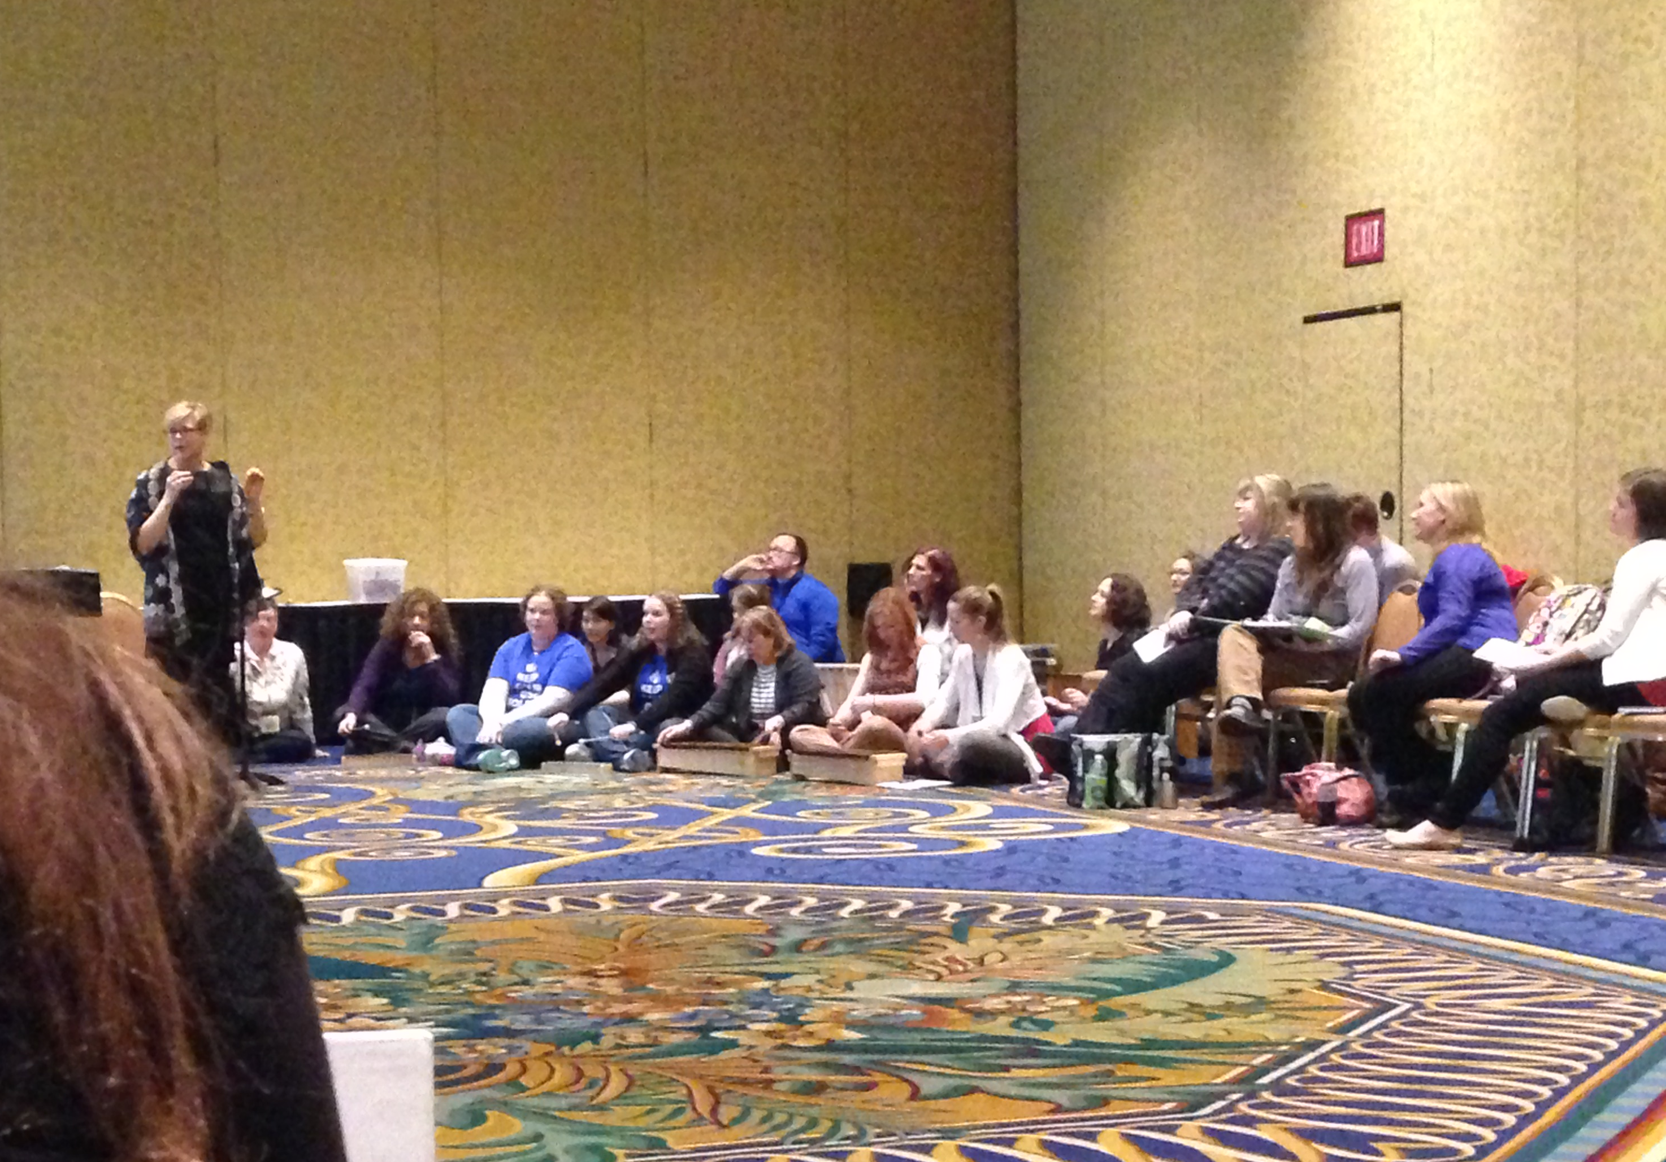
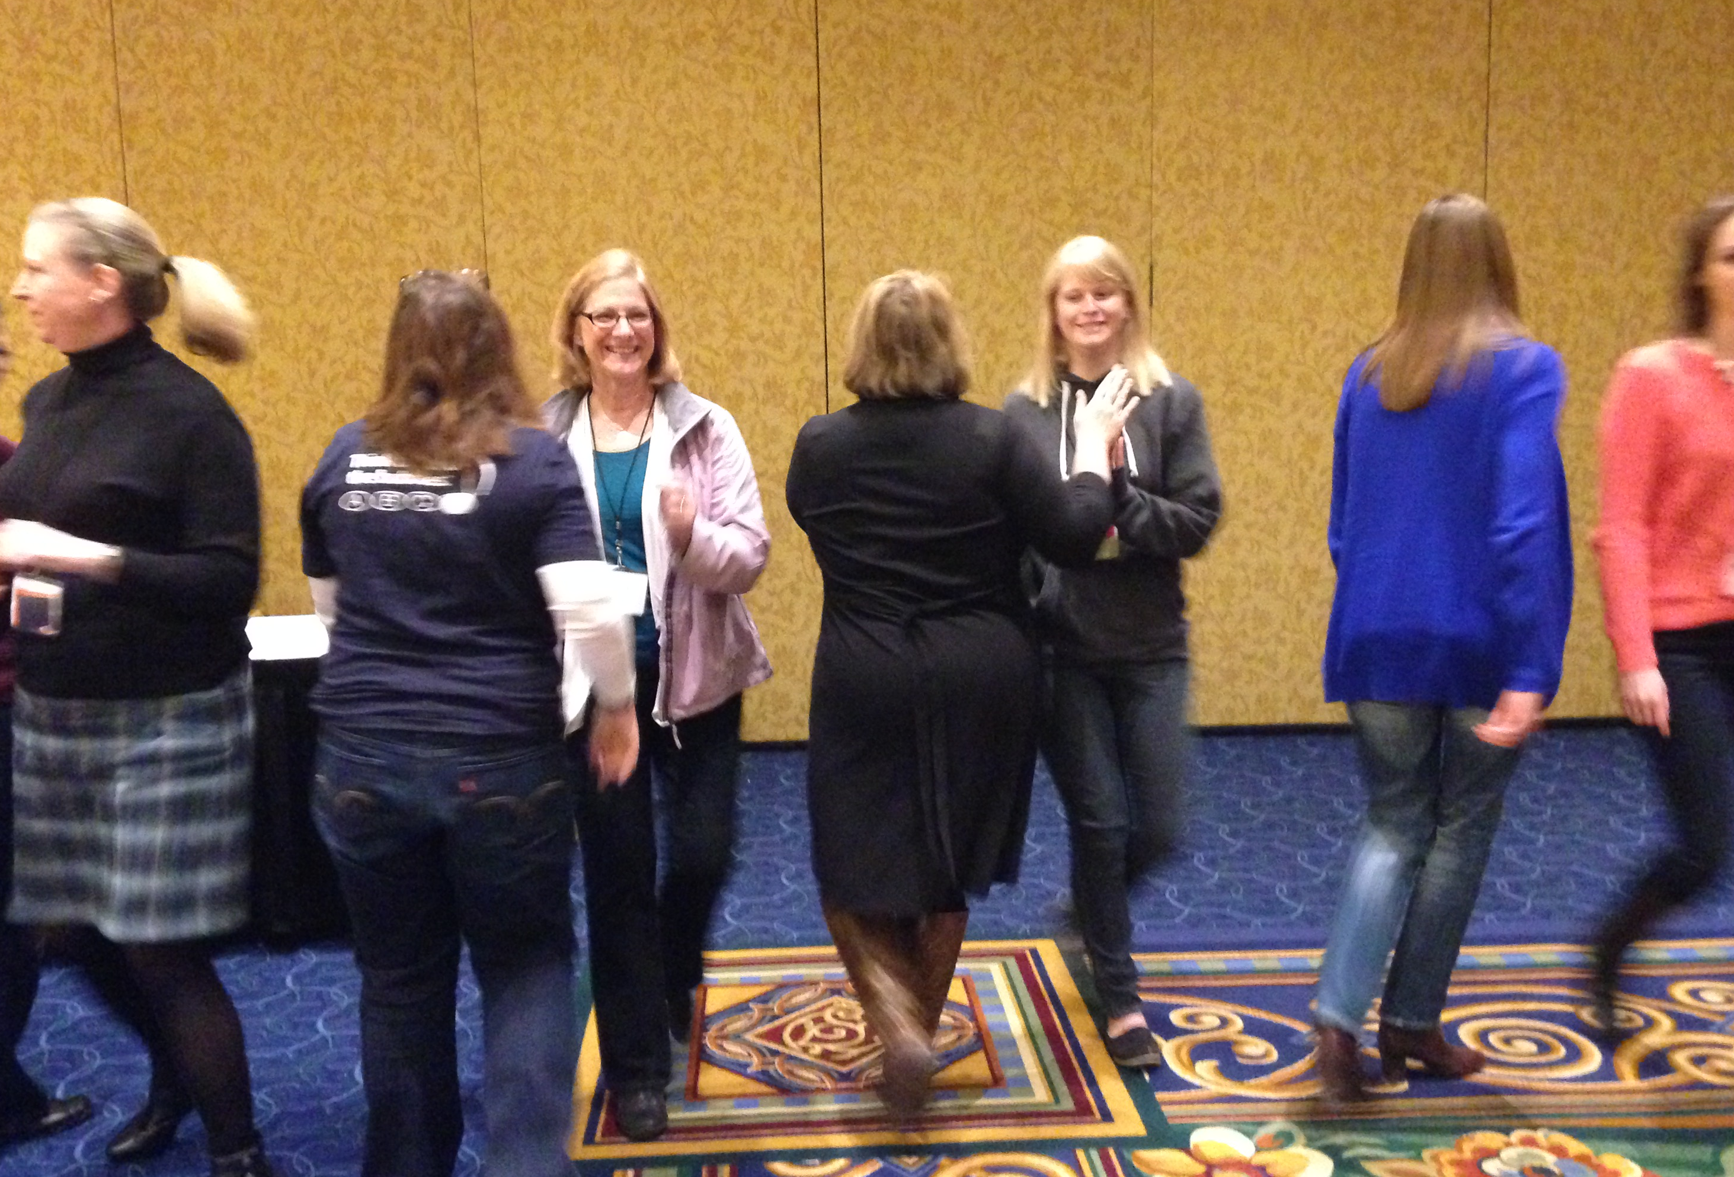
Left:
Hands on using Orff instruments in the Kodály classroom
Right:
Hands on play ripple play party
Left:
Hands on improvisation with play party.

