A Summary of the Study on the Effect of Karrikin on the Germination of Thermodormant Lettuce (Lactuca sativa) Seeds
Kari Miller
Faculty mentor: Dr. Zhong Ma
Department of Biology, Truman State University

Karrikins are compounds found in smoke released from the burning of plants. These compounds have been linked to growth regulation, particularly seed germination. The goal of this project was to examine the effect of karrikin on inducing germination of thermodormant lettuce (Lactuca sativa) seeds. Over the course of the spring 2016 semester, trials were run to determine the germination rates of lettuce seeds treated with different concentrations of the smoke-derived compound karrikin at 33 ̊C, an inhibiting temperature. Our data indicated that karrikin concentrations between 0.2 µM to 0.8 µM increased germination significantly at 33 ̊C, and that 0.4 µM karrikin solution produced the highest germination rate.
In the fall 2016 semester, an object-based image analysis program* was developed to quickly quantify seed germination. By using an image station, clear and consistent pictures were taken which maximized accuracy of the image analysis program (Figure 1). The automated counts were compared to manual counts (Figure 2). It was found that, on average, the percent germination estimated using the automated program was off by 5.16%. This allows for clear distinction between treated and control sets, however, further improvements of the automated program will be necessary. Aided with a more high-throughput approach, it is expected future studies could quickly explore the effects of karrikin on other important food crops, such as rice or corn. Eventually, we hope this research will to the development of effective treatments in agriculture for higher yields with lower seed waste.

*Python script is attached.
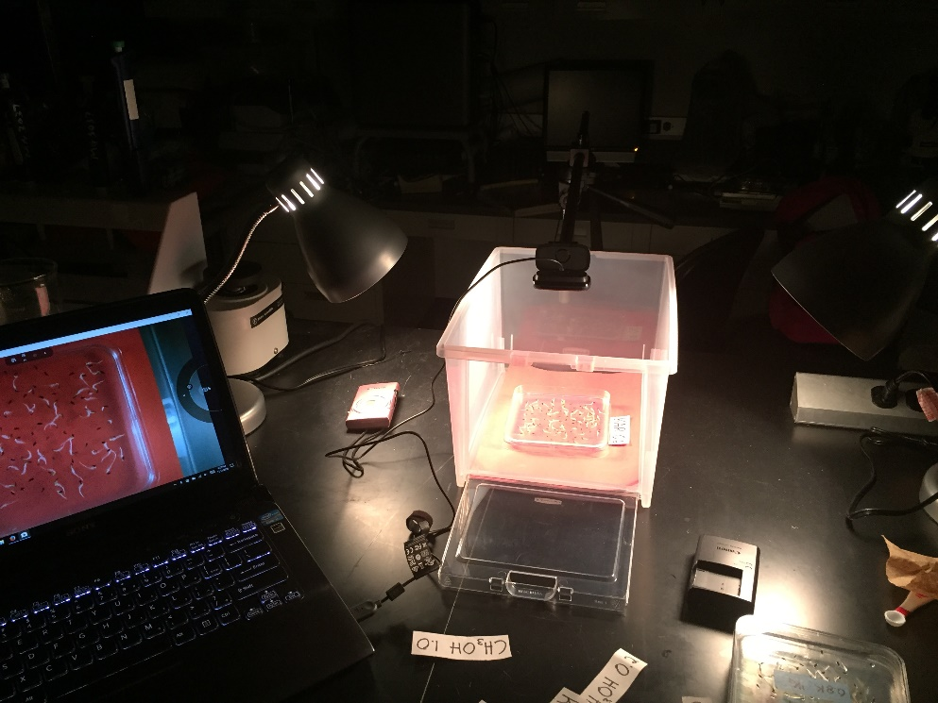
Figure 1. Table-top imaging set-up. The light from two desks lamps was dispersed using a clear plastic container and a red background added contrast to the seeds.

Figure 2: Comparison of manual and automated germination counts.

# A program to estimate germination rates of lettuce seeds.
# 10/21/2016
# by: Kari Miller
# Funded by Truman State University GIASR

# Import necessary packages

import cv2
import numpy as np
import pylab
import scipy
from skimage import color
from skimage import measure

# Function to threshold for total seeds
def thres_seed(image):
blur = cv2.GaussianBlur(image,(5,5),0)
retval, thres = cv2.threshold(blur, 43, 255,cv2.THRESH_BINARY)
grayscaled = cv2.cvtColor(thres,cv2.COLOR_BGR2GRAY)
ret3,thres_img = cv2.threshold(grayscaled,0,255,cv2.THRESH_BINARY+cv2.THRESH_OTSU)
#thres_img = np.invert(thres_img) #maybe remove later
return thres_img

# Function to threshold for germinated roots
def thres_root(image):

blur = cv2.GaussianBlur(image,(5,5),0)
retval, thres = cv2.threshold(blur, 120, 160,cv2.THRESH_BINARY)
grayscaled = cv2.cvtColor(thres,cv2.COLOR_BGR2GRAY)
ret3,thres_img = cv2.threshold(grayscaled,0,255,cv2.THRESH_BINARY+cv2.THRESH_OTSU)
thres_img = np.invert(thres_img)

return thres_img

# Function to determine total seed count
def count_seed(image):

params = cv2.SimpleBlobDetector_Params()

params.blobColor = 0
params.filterByArea = False
params.minArea = 50
params.filterByCircularity = False
params.filterByInertia = False
params.minInertiaRatio = 0
params.filterByConvexity = False

detector = cv2.SimpleBlobDetector_create(params)

keypoints = detector.detect(image)

return len(keypoints)

# Function to determine germinated count
def count_root(image):

params = cv2.SimpleBlobDetector_Params()

params.blobColor = 0
params.filterByArea = True
params.minArea = 50
params.filterByCircularity = False
params.filterByInertia = True
params.minInertiaRatio = 0
params.filterByConvexity = False

detector = cv2.SimpleBlobDetector_create(params)

keypoints = detector.detect(image)

return len(keypoints)

# Main program
def main():

# Import image
date = input("What date did you perform the trial currently in the test folder? ")
imgs = ["0.0_", "0.2K_", "0.4K_", "0.6K_", "0.8K_", "1.0K_", "0.2C_", "0.4C_", "0.6C_", "0.8C_", "1.0C_"]
img_names = []
for name in imgs:
name = name + date + ".jpg"
img_names.append(name)

for image in img_names:
img1 = cv2.imread(image)
img2 = cv2.imread(image)

#threshold for seed count
seed_img = thres_seed(img1)

#determine number of seeds
seeds = count_seed(seed_img)

#threshold for root count
root_img = thres_root(img2)

#determine number of roots
roots = count_root(root_img)

#determine germination percentage
percent = roots/seeds * 100

print("The percent germinated for ", image[:4], " is: ", roots, "/", seeds, " = ", round(percent, 4))

main()

