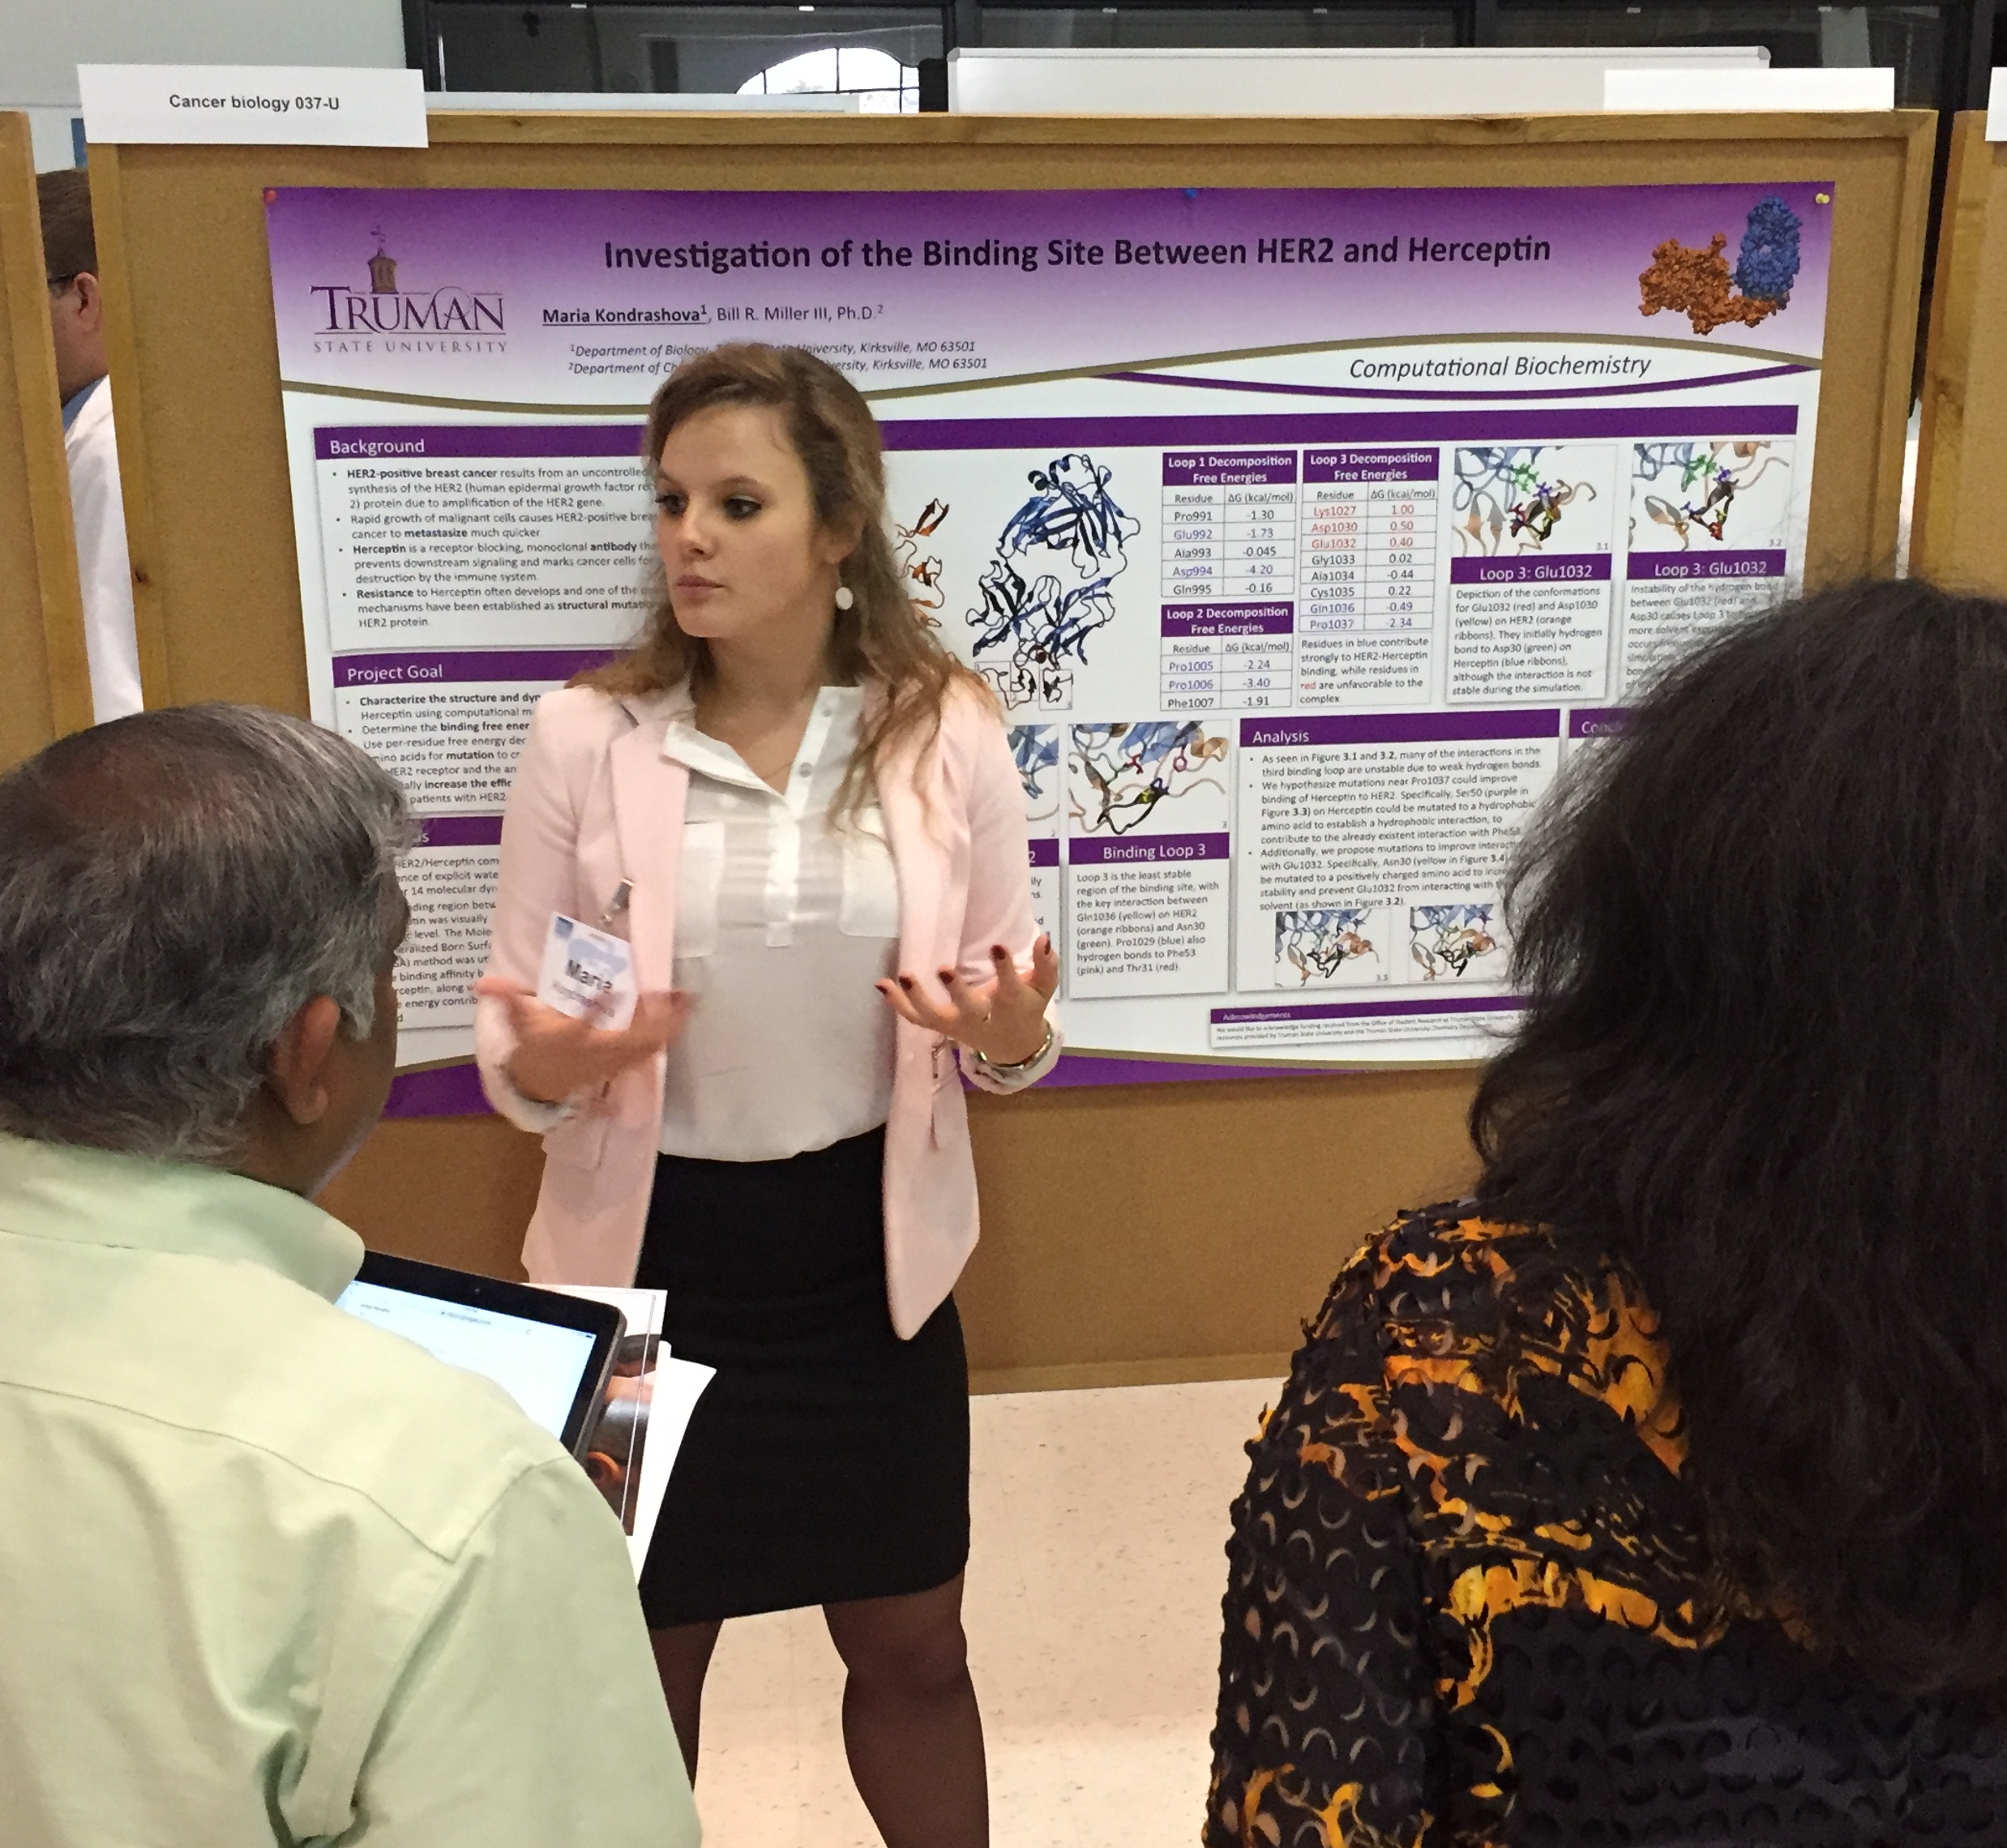

Maria Kondrashova

Mentor: Dr. Bill R. Miller III, Department of Chemistry

Investigation of Affinity at Binding Site Between Human Epidermal Growth Factor Receptor 2 (HER2) and Herceptin

The current study has investigated the binding energies between the HER2 receptor and Herceptin to determine if the amino acid sequence of the drug Herceptin can be altered to create a stronger interaction between the HER2 receptor and the antibody. A stronger interaction between the two would indicate a stronger anti-cancer treatment. Simulations were completed using the AMBER 14 Molecular Dynamics software package. After the simulations were performed, the binding sites of HER2 and Herceptin were analyzed at the atomic level. The Molecular-Mechanics Generalized Born Surface Area (MM-GBSA) method was utilized to quantify binding affinity between HER2 and Herceptin. The calculated binding affinity demonstrated that the HER2-Herceptin complex is energetically stable, as expected, and the per-residue decomposed free energies highlight the favorable and unfavorable residues in the three binding sites. Preliminary results suggest that of the three binding sites/loops, the residues in the third loop (residues 1027-1037) have significantly smaller (unfavorable) energies than the first two binding loops (first loop: residues 991-995 and second loop: residues 1004-1007). Specifically, the least favorable residue in the whole complex is Lys1027, which is the starting residue of the third binding loop. It was determined that Ser50 and Asn30 on Herceptin can be mutated to amino acids that will favor stronger binding with the third loop of HER2. Future research will work towards replacing old residues within the third loop and possibly creating another binding loop to further stabilize the HER2/Herceptin complex.
I also presented at the A.T. Still Interdisciplinary Biomedical Research Conference in November 2016. I was one of twelve students chosen to give an oral presentation at the conference, in addition to my poster presentation. The above photo shows me presenting my poster in front of the judges. My presentation won the Best Undergraduate Research Presentation Award.

