A Summary of the Study of Nerve Regeneration After Injury to the Auditory System of the Adult Cricket Acheta domesticus

Alexis Houser
Faculty Mentor: Dr. Daniela Ostrowski
Department of Biological Sciences, Truman State University

The current study looks at nerve regeneration in the auditory nerve after an injury has occurred causing the nerve to lose its full function. The auditory system in crickets is crucial to their survival and reproduction. Crickets have evolved a mechanism to compensate for injury in the auditory system. This compensatory mechanism can be seen in many different species of field crickets. This response in crickets is very complex; it involves both sprouting of dendrites and of axons as well as synapse formation and functional recover. Performing denervation experiments in animals typically results in neuronal decline and death, but these results are not seen in the cricket. Within the cricket, this compensatory dendritic response has been seen in both the terminal ganglion and prothoracic ganglion. It has been noted that for functional recovery in the auditory system to occur within the cricket, axons and dendrites must grow across the midline, a landmark that typically serves as an inhibitory boundary. Adult crickets detect sound waves with tympanal membranes and associated auditory organs that are located on the tibial section of the cricket’s forelegs. Auditory information is conveyed to the prothoracic ganglion in the central nervous system. Auditory interneurons located in the prothoracic ganglion are arranged in pairs on either side of the midline.
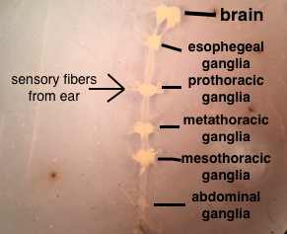
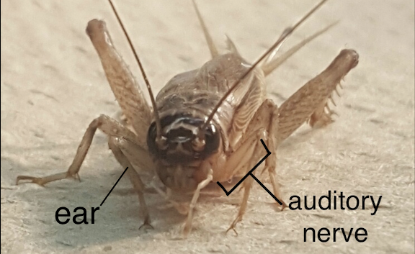

The whole central nervous system of Acheta domesticus showing the location of the ganglia and the sensory fibers leading into the prothoracic ganglia.
Showing the location of the auditory nerve and ear in relation to the rest of the body of the cricket.
The auditory interneurons respond differently depending on what sound they are interpreting. After performing backfills on both male and female crickets using fluorescent dye (biocytin conjugated to Alexa Fluor 594), they were viewed using a confocal microscope. When viewing the tissue filled with fluorescent dye under the confocal microscope, the fluorescent dye highlighted the neuronal connections in the central nervous system, and through synaptic connections, the information is conveyed and is sent to the brain to be further analyzed.

Compressed image showing the auditory nerve filled with the fluorescent dye and seen under a confocal microscope.

A separate study showed that the regeneration rates among male and female crickets were different. Although males had longer regenerated dendrite lengths in the end, the females had a faster regeneration rate at the beginning. The dendritic growth rates were non-linear in females and were linear in males. A possible future study could be to figure out the possible reasoning as to why females would have a faster regeneration rate than males. Ecdysteroids drive metamorphosis and act as sex hormones in insects and are thought to possible influence dendritic and axonal growth. A study could be done to see if ecdysteroids have an influence on the regeneration rates in males and females. I presented my research at the Spring 2017 Student Research Conference at Truman State University.
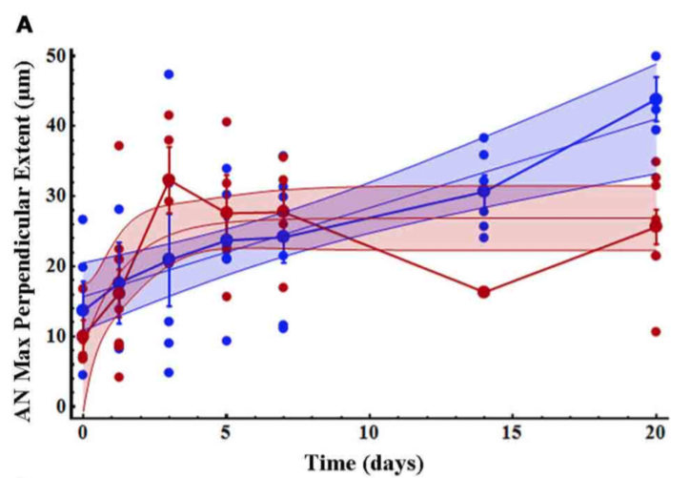
Graph taken from the study done by Alexandra Pfister, Amy Johnson, Olaf Ellers and Hadley W. Horch. Red represents female regeneration rate over a certain time period and blue represents male regeneration rate over a certain time period. This graph shows that initial growth across the midline increased more rapidly in females than males over time after deafferentation.
